User manual for AutoIT

- Copy the software “autoit-v3-sfx.exe” from …\gitrepo\UsefulSoftware to your local drive.
- Unzip the software “autoit-v3-sfx.exe”
- After unzip you will get folder’s and exe
- For recording we can use Au3Record
- go to Extras\Au3Record and double click the Au3Record.exe
- Au3Record window displayed
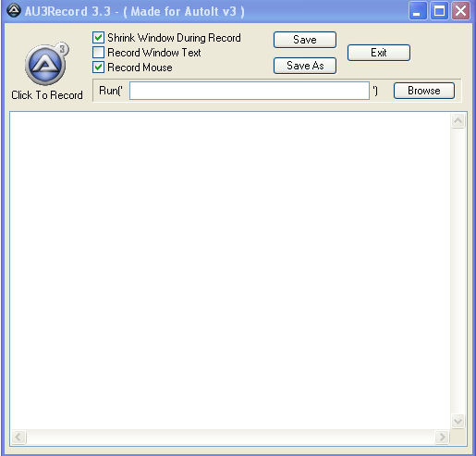

7.Click on the Record Button

The user action will be recorded in the record window
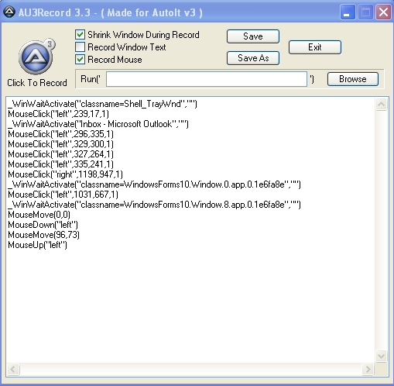

8.To stop the recording click on the stop button
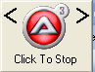

9.Configure the recording while checked and uncheck the below check box

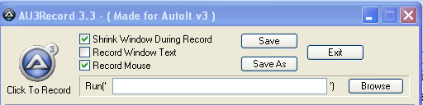

10.To save the script click save button.
11.The script will be saved in the “.au3” format

12If want to open application for recording browse the application exe and than click recording button. Autoit will open the application and start recording

13.Want to Edit and add script the Autoit script than go to folder “SciTe” and double click SciTE.exe. It will open the SciTE4Autoit window.
Here people can edit and add script manually and save it.

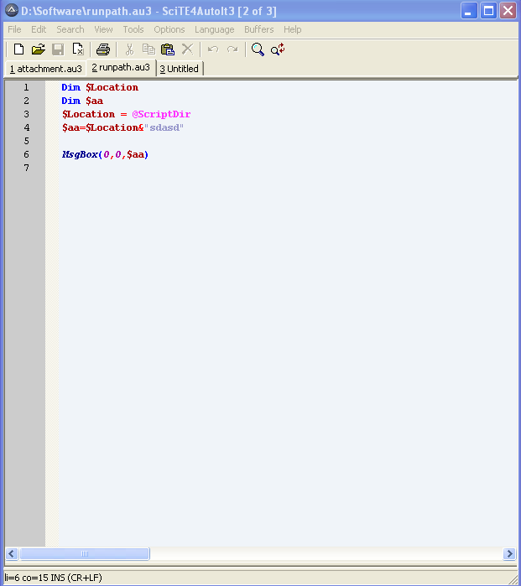
14.to convert the autoit script into exe than go to folder “Aut2Exe” and double click
Aut2exe.exe
Aut2Exe window opened.
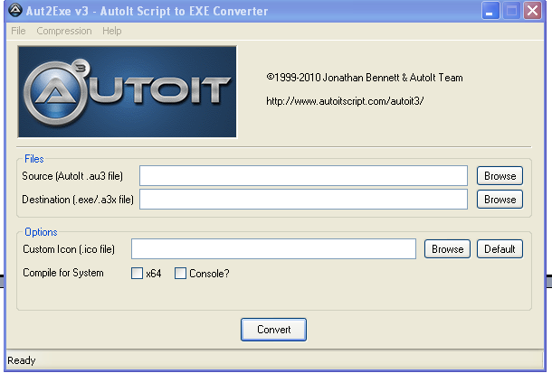

15. Click first browse button to browse the script which needed to convert into exe
16.select second browse button to locate the drive/place you want to place the exe file

16.Click convert and the exe is produce at the destination location

If error displayed at the time of convert than some problem in the script.

17 .now you can execute the exe file where ever you want to place and execute it it will perform the recorded action

